Moments & Equilibrium
Centre of mass: The point at which all the mass of the object appears to be concentrated.
The centre of mass isn’t necessarily in the centre of the object.
A moment of a force or torque results when you apply a force to an object in such a way that it isn’t directed through its centre of mass. As a result, the mass will change its speed of rotation.
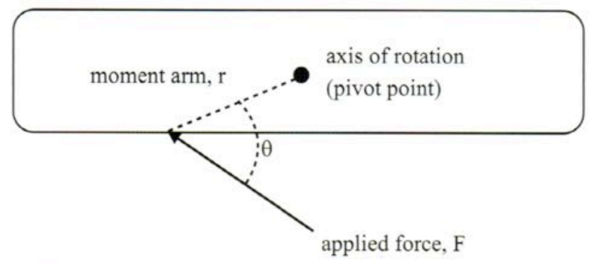
τ = rFsinθ
Where:
- τ is torque (Nm).
- r is distance between the line of action of force and the axis of rotation.
- F is applied force (N).
- θ is angle between the line of action of force and the moment arm.

Conditions for static equilibrium:
At rest or in a state of uniform straight line motion: ∑F = 0
However, even with this condition satisfied, a body can still undergo rotational acceleration in the case where the lines of action of 2 opposing parallel forces of equal magnitude don’t coincide.
Rotational equilibrium: ΣM = 0
Σ(anticlockwise moments) = Σ(anticlockwise moments)

The simplest way to find the centre of mass of an object is to find the point about which it balances. This is usually the geometrical centre of the object if it’s in regular shape and uniform in density.
A convenient way where practicable is to suspend the object. The centre of mass will lie directly below it. By repeating the process from a different suspension point, the exact location of the centre of mass is found.
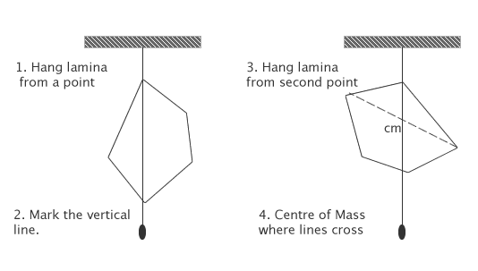
The stability (static equilibrium) of an object or structure depends very much on the position of its centre of mass in relation to its support. A body may be in either stable, neutral or unstable equilibrium.

NEUTRAL
UNSTABLE
STABLE
Any sideways movement will cause the centre of mass to be raised.
Any sideways movement will lower the centre of mass.
Any sideways movement will neither raise nor lower the centre of mass.

A structure will become unstable and topple if the line of its centre of mass falls outside the object’s base.
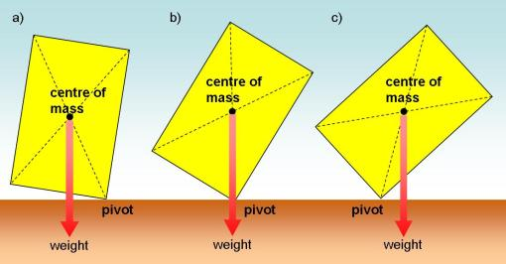
UNSTABLE
STABLE
STABLE

Direction of torque – right hand grip rule:
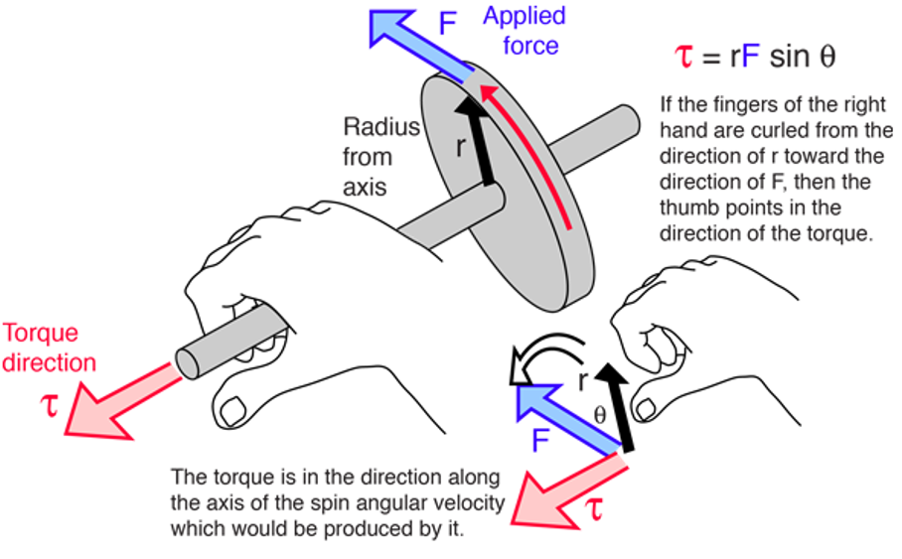

Cables supporting a load:
Q: A large decoration weighing 441N is being supported by 2 cables as shown. Determine the tension in each cable.
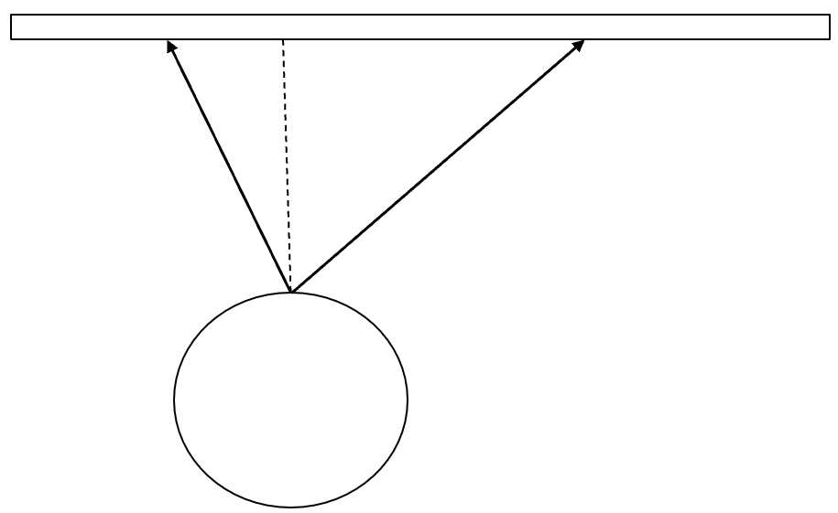
T₁
T₂
35°
50°
ΣF_{y} = 0 → T₂ cos35 + T₁ cos50 = 441
ΣF_{x} = 0 → T₂ sin35 = T₁ sin50
$\frac{T_{1}sin50}{sin35}$cos35 + τ₁ cos50 = 441
T₁($\frac{sin50}{sin35}$cos35 + cos50) = 441
T₁ = 254N
T₂ = $\frac{254 sin50}{sin35}$ = 339N

Will it tip?
Q: A large limestone block 80cm high and 60cm wide is to be tipped over by applying a force at the top as shown. The mass of the block is 385kg and the force being applied is 1500N. Will it tip over? Assume no sliding occurs.
0.6m
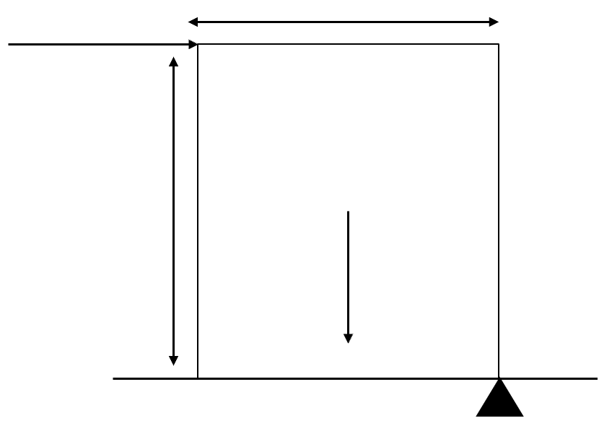
3773N
0.8m
1500N
Στ(clockwise) = (0.8)(1500) = 1200Nm
Στ(anticlockwise) = (0.3)(3773) = 1132Nm
Στ (anticlockwise) < Στ(clockwise) → the block will tip over.

Drawbridge problem – a supported cantilever:
Q: A bridge that can be raised to allow boats to pass under it is 9.6m long and attached to a cable inclined 35° to the horizontal. The mass of the bridge is 12 tonnes, and the cable is attached 7.2m form the pivot point. The bridge is horizontal and just being raised from its ground support. Determine:
[a] The tension force in the cable.
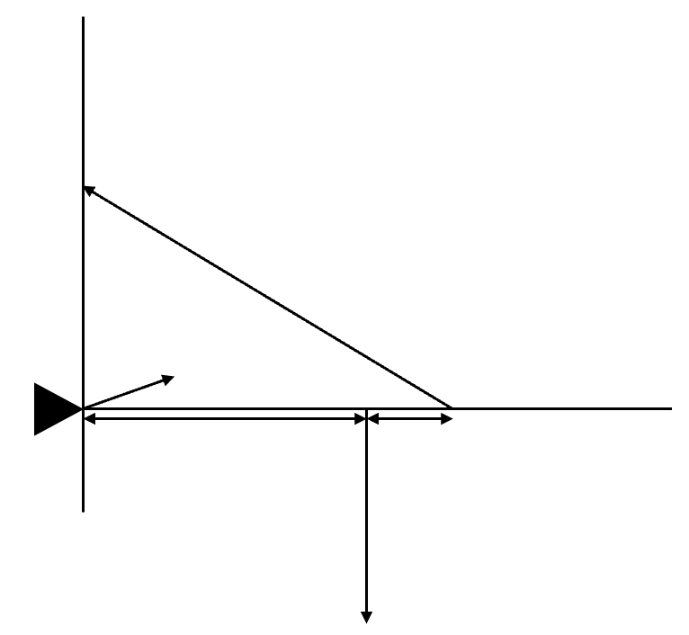
118kN
2.4m
4.8m
R
T
35°

Στ(clockwise) = Στ(anticlockwise)
Στ(clockwise) = (4.8)(118000) = 564000Nm
Στ(anticlockwise) = (7.2)( Tsin35)
564000 = (7.2)(Tsin35) → T = 1.37 x 10⁵N

[b] The reaction force of the pivot.
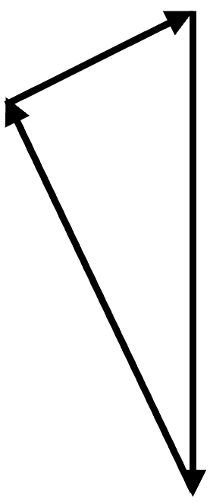
θ
55°
1.37 x 10⁵
118000
R

ΣF = 0
R = $\sqrt{{(1.37 x 10^{5})}^{2}+{118000}^{2} –2\left(1.37 x {10}^{5}\right)\left(118000\right)cos55}$ =
= 1.19 x 10⁵N
$\frac{sinθ}{1.37 x 10^{5}}$ = $\frac{sin55}{1.19 x {10}^{5}}$ → θ = 70.7°
R = 1.19 x 10⁵N at 70.5° to the wall

Ladder problem:
Q: Rob is investigating some storm damage and is using an 18.5kg ladder of total length 4.80m. The ladder is inclined at 72° to the horizontal and is resting on rough ground. Rob’s weight is 735N and he’s situated 3.60m from the bottom of the ladder. Determine:
[a] The force exerted by the wall on the top of the ladder. Assume the wall is smooth.
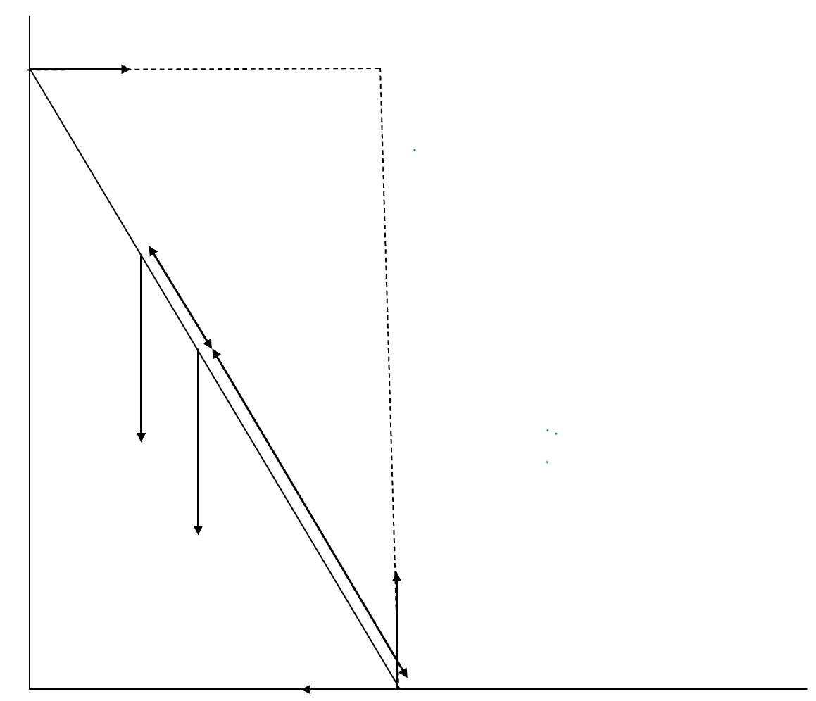
4.8cos18
R_{x}
R_{y}
R_{w}
181N
735N
1.2m
2.4m
72°

ΣF_{y} = 0 → R_{y} = 181 + 735 = 916N
ΣR_{x} = 0 → R_{w} = R_{x}
Στ(clockwise) = Στ(anticlockwise)
(4.8cos18)R_{w} = 735(3.6cos72) + 181(2.4cos72)
R_{w} = 209N

[b] The minimum force of friction required for the ladder not to slip.
R_{x} = R_{w} = 209N

[c] The total reaction force exerted by the ground.
209
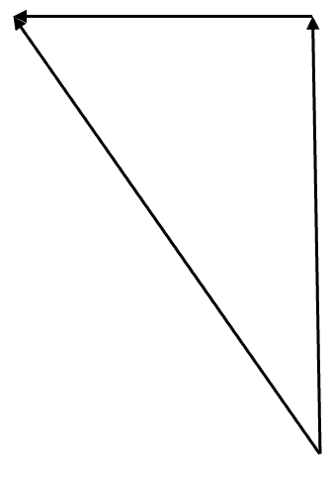
θ
R
916
R = $\sqrt{{209}^{2}+{916}^{2}}$ = 9.40 x 10²N
θ = tan⁻¹($\frac{209}{916}$) = 12.8°
R = 9.40 x 10²N 12.8° to the vertical

Simple lever:
Q: John is using a lever of mass 6.7kg to raise a heavy rock of mass 85kg. The lever is 2.1m in length. The rock is 20cm from one end and 30cm from the pivot point.
[a] Draw a vector diagram to show all forces.
F
R
833N
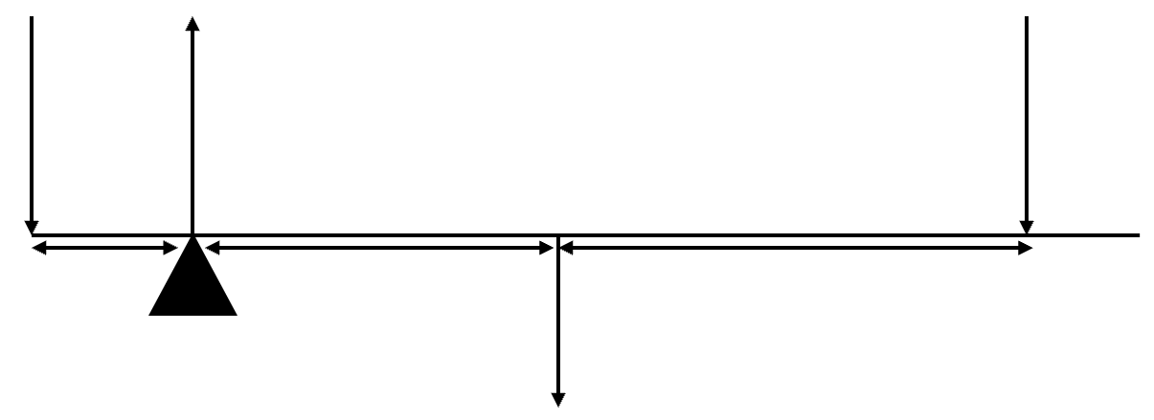
0.3m
0.55m
1.05m
65.7N
[b] Determine the force that John has to apply downwards to just lift the rock.
Στ(clockwise) = Στ(anticlockwise)
(0.55)(65.7) + (1.6)F = (0.3)(833) → F = 134N

[c] What’s the reaction force at the pivot?
ΣF_{y} = 0 → R = 833 + 65.7 + 134 = 1.03 x 10³N

Simple bridge:
Q: A small truck of mass 3.5 tonnes and a car of mass 950kg are situated on a bridge. The truck is 4.2m from A and the car 3.6m from B. The bridge has a weight of 350kN and is 16m long. Determine the reaction forces at ends A and B.
9310N
34.3kN
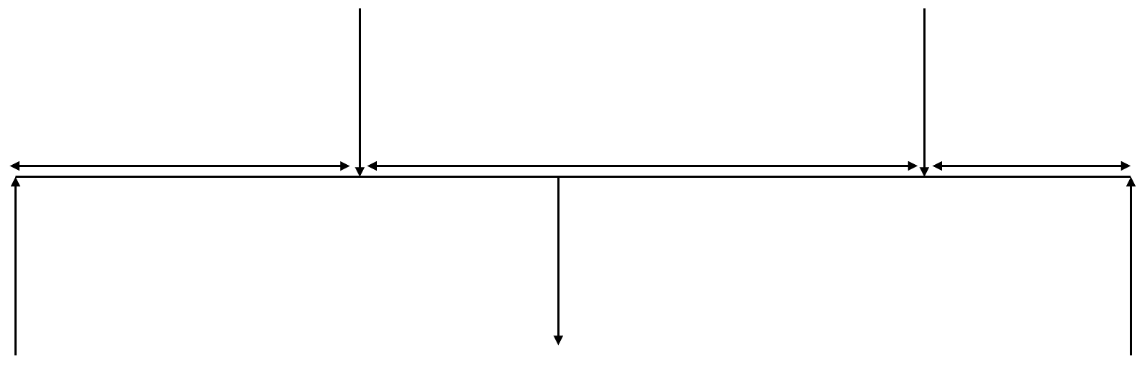
350kN
3.6m
8.2m
4.2m
R_{B}
R_{A}

Στ(anticlockwise) = Στ(clockwise)
16R_{B} = (8)(350000) + (4.2)(34300) + (12.4)(9310)
R_{B} = 191kN
ΣF_{y} = 0 → R_{A} + R_{B} = 34300 + 350000 + 9310
R_{B} = 191000 → RA + 191000 = 34300 + 350000 + 9310
R_{A} = 202kN

Set 2
Q: Explain why buses and trucks usually have much larger diameter steering wheels than normal passenger cars have, while racing cars usually have smaller diameter steering wheels than normal passenger cars have.
The truck has a very heavy steering mechanism. As a consequence it will require a lot of torque to get it to turn. By increasing the diameter of the steering wheel, the torque that can be created when the driver applies their force to the wheel will be maximised. A large wheel provides a force (torque advantage).
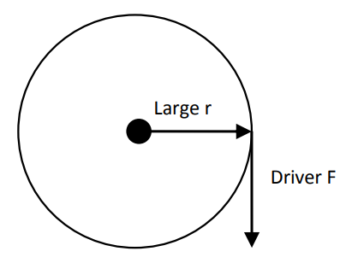
The racing car has a very light steering mechanism. What is important is that the driver be able to respond quickly to changes in conditions in front of them. A small steering wheel does not have to be turned through a large distance in order to bring about a change in the direction of the vehicle. A small radius steering wheel provides a shortness of turning distance advantage.
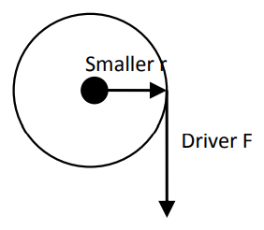
Q: While hiking through the bush carrying a heavy backpack, Michael finds himself leaning forwards as he walks. Explain.
Michael leans forward to keep the combined centre of mass (his com and the backpacks com combined) above his base. This causes the weight vector of the combined com to act through the base eliminating any toppling torque. If he does not lean forward the weight of the combined centre of mass acts outside his base (feet behind the heels) and this causes him to topple over backwards.
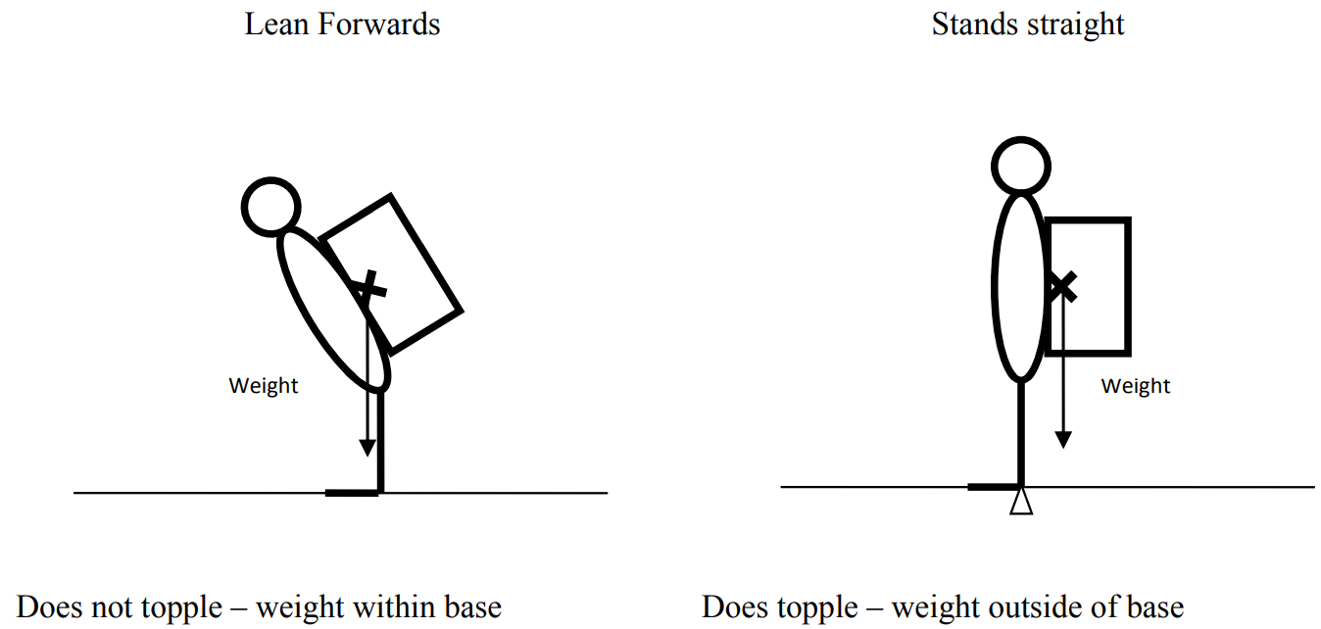
Q: When Jackie replaced the standard tyres on her sports car with a set of low profile tyres, the car seemed more powerful and was able to achieve greater acceleration. Explain.
For a constant torque the larger the radius the smaller the force. The smaller the force the smaller the acceleration of the car by F = ma.
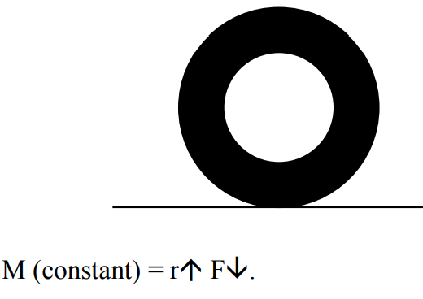
For a constant torque the smaller the radius the larger the force. The larger the force the greater the acceleration of the car by F = ma.
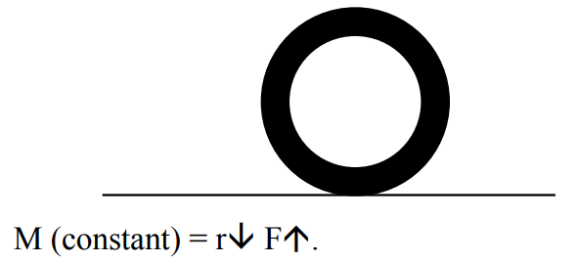
Q: Engineers design racing cars with a low centre of mass and widely spaced wheels to improve their high speed cornering ability. Explain, using moments, the physics on which they have this design.
When a car goes around a corner on a flat road it is the outside tyres that tend to provide the centripetal force by friction required to round the bend. If the torque provided by the outer tyres accelerating towards the centre of the curve is greater than the torque provided by the normal force acting on the tyre, the racing car will roll over.
Because the racing car is accelerating around the bend, torques must be taken about the centre of mass of the object. This is different to when the object is:
- In stable equilibrium – the pivot can be chosen arbitrarily.
- In unstable equilibrium – the pivot is taken about the point base.
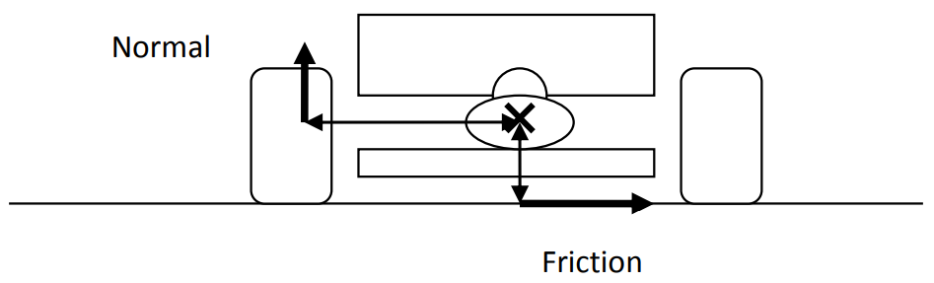
Q: At the end of a long day of painting his 2-storey house, Keith finds that he can’t quite reach a part of the external wall near a balcony. He decides to improve and use a heavy plank that’s about 4m long and has a mass of 37.5kg. Describe a simple way Keith could use to increase this distance.
Move the com of the plank further form the edge or put the paint can at the opposite end of the plank to add extra stabilising torque to the plank.

Q: In a science experiment, several students tried to touch their toes while they stood with their backs to the wall. They found that this wasn’t possible if their heels were touching the base of the wall and they kept their legs straight. Explain.
With the backs of their legs to the wall, as they bend forward, the centre of mass of their body is put outside their base and they topple forward. They can only achieve this if they can keep the centre of mass inside their base (feet) at all times which is impossible so they fall / topple.

Q: By inverting your body to a handstand position, your centre of mass moves much closer to the ground. A lower centre of mass should give you more stability. Why is it more difficult to remain in a handstand position than to stand upright as normal?
While your com is closer to the ground, the size of you base (hands) is much smaller than usual (your feet). This results in you (the handstand) being less stable than usual.

Q: Explain why you can’t avoid swaying from side to side when you try to walk along a straight line with your arms folded.
You need to shift your centre of mass from side to side to keep it above the foot that is on the ground to avoid inducing a torque that causes you to topple.

Q: Good hurdlers have a distinctive action as they clear each hurdle in a race – they lean their upper bodies well forward close to the horizontal as they stride over each hurdle. Explain.
By leaning forward as you pass over the hurdle, it minimises the fluctuation in the change in height of the centre of mass of the hurdler. When the com of the hurdler rises, the potential energy of the hurdler increases. By the law of conservation of energy, if your potential energy increases then your kinetic energy and consequently velocity decreases. A slow velocity causes you to travel the distance of the race in a longer time. Hence you have a greater chance of losing.

Q: Below is a diagram of a novelty one-bottle wine rack. It consists of a flat piece of wood 80mm wide, 15mm thick and 200mm long. An angled hole at one end fits the neck of a bottle. The rack, when holding a bottle, is quite stable if you stand it on a flat table as shown. Explain the critical factor in its design. Would one design suit all bottles?
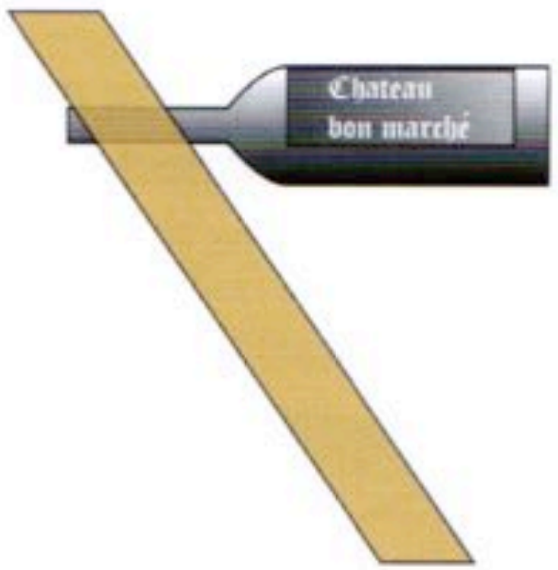
The critical factor is that the centre of mass of the wood bottle system is above the base so that the weight force acts through the base. If the weight force did not act through the base, a torque would be induced that would topple the system.

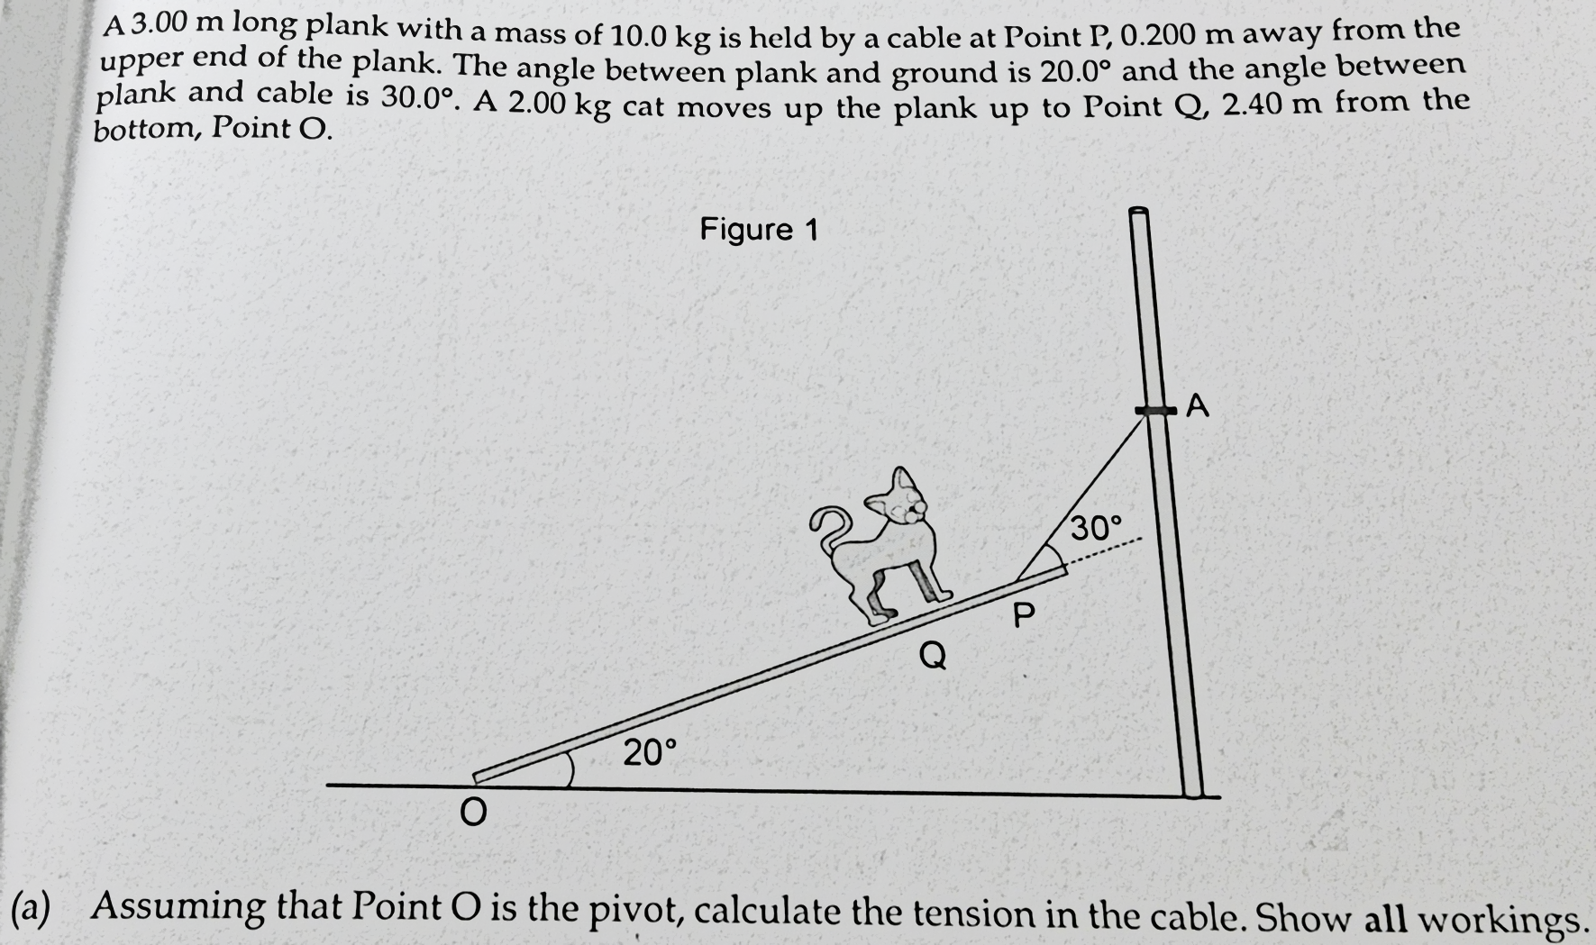
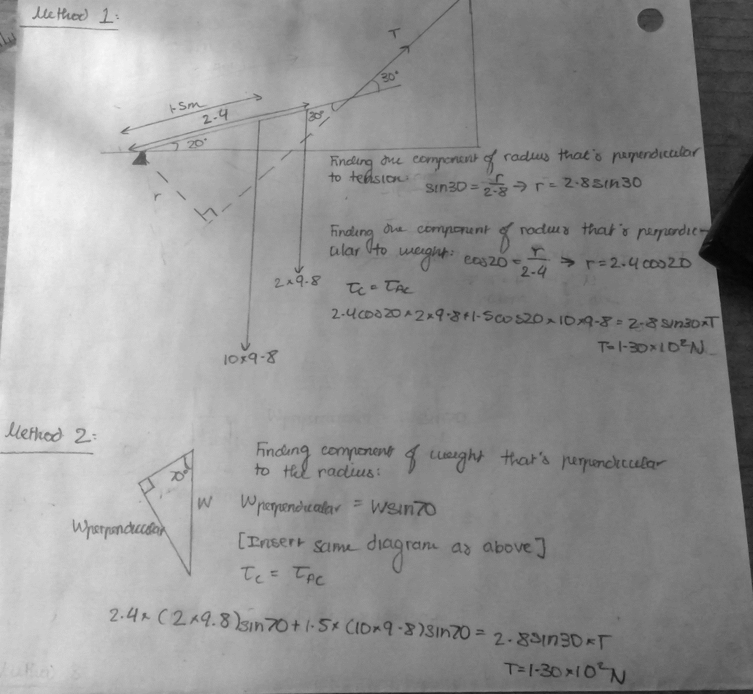

Either find the component of radius that’s perpendicular to the force or find the component of force that’s perpendicular to the radius. Don’t try to put everything into one plane i.e., finding the vertical components of the forces and the horizontal components of all the radii. Don’t find the horizontal component of the radius and the vertical component of the force for any force. If you need to do that, draw a line from the pivot that meets that hits the force at right angles → solve for that (can be in terms of another variable e.g., T or can be constant).
If there’s a weight force that acts through the pivot, don’t include that weight force when you find the vector sum of weight force and tension to find reaction force (don’t include it in the sum to find weight).

